NLP Lab Session Week 9
More on Features and Evaluation for Classification
Part 4: Evaluation Measures: Precision, Recall and F1

Continuing our session with the movie review sentences

Other Evaluation Measures

So far, we have been using simple accuracy for a performance evaluation measure of the predictive capability of the model that was learned from the training data. But we can learn more by looking at the predictions for each of the labels in our classifier.

We start by looking at the confusion matrix, which shows the results of a test for how many of the actual class labels (the gold standard labels) match with the predicted labels. In this diagram the two labels are called “Yes” and “No”.

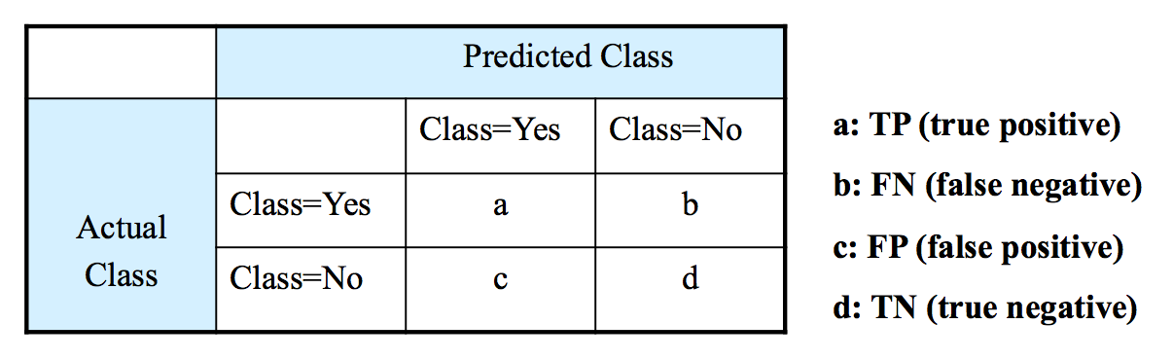

When the predicted class is the same as the actual class, we call those examples the true positives. When the actual class was supposed to be Yes, but the predicted class was No, we call those examples the false negatives. When the actual class is No, but the classifier incorrectly predicted Yes, we call those examples the false positives. The true negatives are the remaining examples that were correctly predicted No. The number of each of these types of examples in the test set is put into the confusion matrix.

Note that the intuition for the terminology comes from the idea that we are trying to find all the examples where the class label is Yes, the positive examples. The false positives represent the positives which were predicted Wrong, and the false negatives represent the positives that were Missed. This idea originated in the Information Retrieval field where the Yes answers represented documents that were correctly retrieved as the result of a search.

In keeping with this intuition, two commonly used measures come from IR, where IR is only interested in the positive labels.

recall = TP / ( TP + FP ) (the percentage of actual yes answers that are right)
precision = TP / ( TP + FN ) (the percentage of predicted yes answers that are right)

These two measures are sometimes combined into a kind of average, the harmonic mean, called the F-measure, which in its simplest form is:

F-measure = 2 * (recall * precision) / (recall + precision)

In situations where we are equally interested in correctly predicting Yes and No, and the numbers of these are roughly equal, then we may compute precision and recall for both the positive and negative labels. And we can also use the accuracy measure.

accuracy = TP + TN / (TP + FP + FN + TN) (percentage of correct Yes and No out of all text examples)

In the NLTK, the confusion matrix is given by a function that takes two lists of labels for the test set. NLTK calls the first list the reference list, which is all the correct/gold labels for the test set, and the second list is the test list, which is all the predicted labels in the test set. These two lists are both in the order of the test set, so they can be compared to see which examples the classifier model agreed on or not.

First we build the reference and test lists from the classifier on the test set, but we will call them the gold list and the predicted list.

goldlist = []
predictedlist = []
for (features, label) in test_set:
goldlist.append(label)
predictedlist.append(classifier.classify(features))

We can look at the first 30 examples and think about whether the corresponding elements of the last match.

print(goldlist[:30])
print(predictedlist[:30])

Now we use the NLTK function to define the confusion matrix, and we print it out:

cm = nltk.ConfusionMatrix(goldlist, predictedlist)
print(cm.pretty_format(sort_by_count=True, show_percents=True, truncate=9))

| n p |
| e o |
| g s |
----+---------+
neg |<375>125 |
pos | 148<352>|
----+---------+
(row = gold; col = predicted)

In our movie sentences classification task, we have two class labels: ‘neg’ and ‘pos’ (instead of Yes and No). If we consider the ‘pos’ class as the positive class and the ‘neg’ as the negative class, then this confusion matrix is reversed from our previous version, and there are 352 True Positives, 375 True Negatives, 125 False Positives and 148 False Negatives. Since this classification task is symmetric with respect to the two classes, we can flip the terminology and consider the ‘neg’ class as positive and the ‘pos’ class as negative. In that case, there are 375 True Positives, 352 True Negatives, 148 False Positives, and125 False Negatives.

Since we are interested in both the ‘pos’ and ‘neg’ classes, we next want to compute precision, recall and F1 for each class. There are NLTK functions to do this, but they require a lot of setup to get the input in the correct forms.

Instead, I have written a function that takes the gold list and the predicted list, computes the True Positives, True Negatives, False Positives, False Negatives and then uses those to compute the other measures for each class. I called this function eval_measures.

# Function to compute precision, recall and F1 for each label
# and for any number of labels
# Input: list of gold labels, list of predicted labels (in same order)
# Output: prints precision, recall and F1 for each label
def eval_measures(gold, predicted):
# get a list of labels
labels = list(set(gold))
# these lists have values for each label
recall_list = []
precision_list = []
F1_list = []
for lab in labels:
# for each label, compare gold and predicted lists and compute values
TP = FP = FN = TN = 0
for i, val in enumerate(gold):
if val == lab and predicted[i] == lab: TP += 1
if val == lab and predicted[i] != lab: FN += 1
if val != lab and predicted[i] == lab: FP += 1
if val != lab and predicted[i] != lab: TN += 1
# use these to compute recall, precision, F1
recall = TP / (TP + FP)
precision = TP / (TP + FN)
recall_list.append(recall)
precision_list.append(precision)
F1_list.append( 2 * (recall * precision) / (recall + precision))

# the evaluation measures in a table with one row per label
print('\tPrecision\tRecall\t\tF1')
# print measures for each label
for i, lab in enumerate(labels):
print(lab, '\t', "{:10.3f}".format(precision_list[i]), \
"{:10.3f}".format(recall_list[i]), "{:10.3f}".format(F1_list[i]))

Now we can call this function on our data.

eval_measures(goldlist, predictedlist)

Precision Recall F1
neg 0.750 0.717 0.733
pos 0.704 0.738 0.721

This gives us more information into the performance of the model for each label. We can see that the ‘neg’ label is predicted with higher precision, .75, while the ‘pos’ label is predicted with higher recall, .738.

